**CHAPTER 3**

**METHODOLOGY**

**3.1 HARDWARE REQUIREMENTS**

The UNO is the best board to get started with electronics and coding. If this is your first experience tinkering with the platform, the UNO is the most robust board you can start playing with the UNO is the most used and documented board of the whole Arduino family.

**3.1.1 ARDUINO UNO MICROCONTROLLER:**

The Arduino Uno is a microcontroller board based on the ATmega328 (datasheet). It has 14 digital input/output pins (of which 6 can be used as PWM outputs), 6 analog inputs, a 16 MHz ceramic resonator, a USB connection, a power jack, an ICSP header, and a reset button.

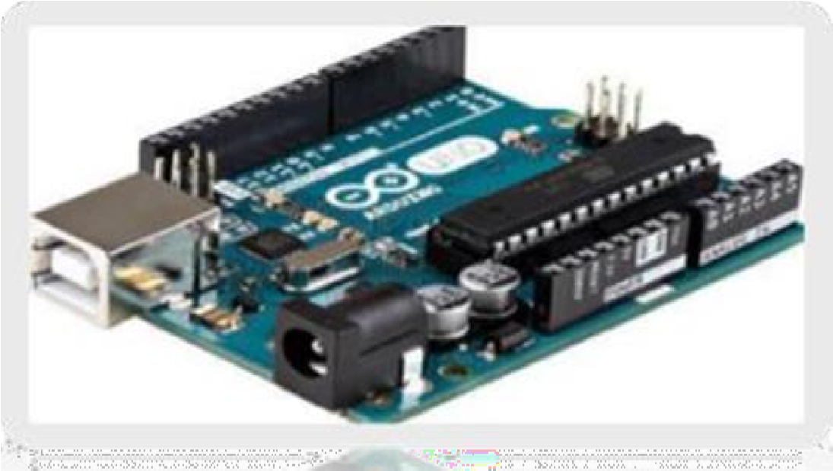

**FIGURE 3.1:** Arduino UNO Broad

It contains everything needed to support the microcontroller; simply connect it to a computer with a USB cable or power it with a AC-to-DC adapter or battery to get started. The Uno differs from all preceding boards in that it does not use the FTDI USB-to-serial driver chip.

Instead, it features the Atmega16U2 (Atmega8U2 up to version R2) programmed as a USB-to-serial converter.

**Revision 2** of the Uno board has a resistor pulling the 8U2 HWB line to ground, making it easier to put into DFU mode.

**Revision 3** of the board has the following new features:

* Stronger RESET circuit.
* Atmega 16U2 replace the 8U2.
* 1.0 pinout: added SDA and SCL pins that are near to the AREF pin and two other new pins laced near to the RESET pin, the IOREF that allow the shields to adapt to the voltage provided from the board. In future, shields will be compatible both with the board that use the AVR, which operate with 5V and with the Arduino Due that operate with 3.3V.

**3.1.2 ARDUINO UNO TECHNICAL SPECIFICATIONS**

# **TABLE 3.1 :** Technical Specifications

|  |  |
| --- | --- |
| **Microcontroller** | **ATmega328P – 8-bit AVR family microcontroller** |
| Operating Voltage | 5V |
| Recommended Input Voltage | 7-12V |
| Input Voltage Limits | 6-20V |
| Analog Input Pins | 6 (A0 – A5) |
| Digital I/O Pins | 14 (Out of which 6 provide PWM output) |
| DC Current on I/O Pins | 40 Ma |
| DC Current on 3.3V Pin | 50 mA |
| Flash Memory | 32KB (0.5KB is used for Bootloader) |
| SRAM | 2 KB |
| EEPROM | 1 KB |
| Frequency (Clock Speed) | 16 MHz |

Arduino Uno is a microcontroller board based on 8-bit ATmega328P microcontroller. Along with ATmega328P, it consists other components such as crystal oscillator, serial communication, voltage regulator, etc. to support the microcontroller. Arduino Uno has 14 digital input/output pins (out of which 6 can be used as PWM outputs), 6 analog input pins, a USB connection, A Power barrel jack, an ICSP header and a reset button. The 14 digital input/output pins can be used as input or output pins by using pin Mode(), digital Read() and digital Write() functions in arduino programming. Along with 14 Digital pins, there are 6 analog input pins, each of which provide 10 bits of resolution, i.e. 1024 different values.

**3.1.3 COMMUNICATION**

Arduino can be used to communicate with a computer, another Arduino board or other microcontrollers. The ATmega328P microcontroller provides UART TTL (5V) serial communication which can be done using digital pin 0 (Rx) and digital pin 1 (Tx).An ATmega16U2 on the board channels this serial communication over USB and appears as a virtual com port to software on the computer. The ATmega16U2 firmware uses the standard USB COM drivers, and no external driver is needed.

However, on Windows, a .in file is required. The Arduino software includes a serial monitor which allows simple textual data to be sent to and from the Arduino board. There are two RX and TX LEDs on the arduino board which will flash when data is being transmitted via the USB-to-serial chip and USB connection to the computer (not for serial communication on pins 0 and 1). A Software Serial library allows for serial communication on any of the Uno's digital pins. The ATmega328P also supports I2C (TWI) and SPI communication. The Arduino software includes a Wire library to simplify use of the I2C bus.

**3.1.4 PIN DESCRIPTION OF ARDUINO UNO:**

When ATmega328 chip is used in place of Arduino Uno, or vice versa, the image below shows the pin mapping between the two. Each pin operate at 5V and can provide or receive a maximum of 40mA current, and has an internal pull-up resistor of 20-50 KOhms which are disconnected by default.

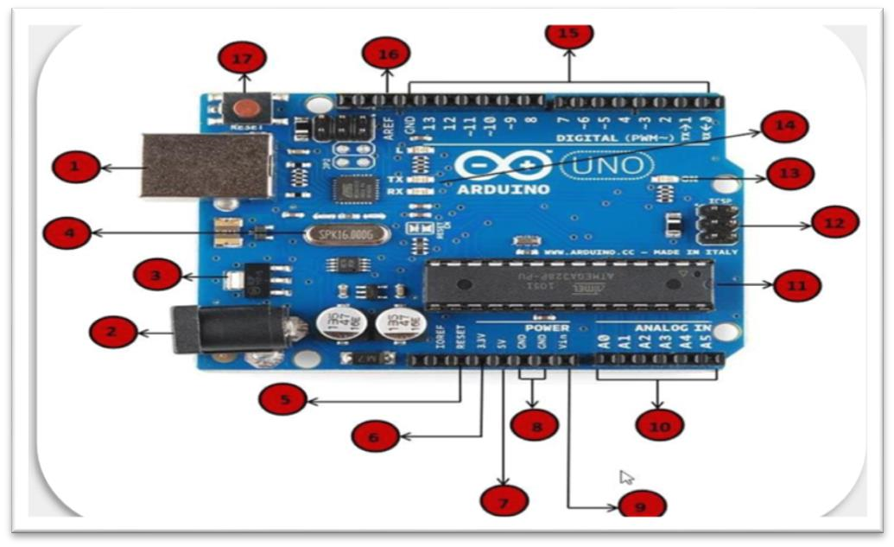

**FIGURE 3.2 :** Arduino Uno to ATmega328 pin mapping

**PIN NO.1 - Power USB :** Arduino board can be powered by using the USB cable from your computer. All you need to do is connect the USB cable to the USB connection.

**PIN NO.2 - Power (Barrel Jack) :** Arduino boards can be powered directly from the AC mains power supply by connecting it to the Barrel Jack .

**PIN NO.3 - Voltage Regulator :** The function of the voltage regulator is to control the voltage given to the Arduino board and stabilize the DC voltages used by the processor and other elements.

**PIN NO. 4 - Crystal Oscillator :** The crystal oscillator helps Arduino in dealing with time issues. How does Arduino calculate time? The answer is, by using the crystal oscillator. The number printed on top of the Arduino crystal is 16.000H9H. It tells us that the frequency is 16,000,000 Hertz or 16 MHz.

**PIN NO. 5, 1 - 7 Arduino Reset :** You can reset your Arduino board, i.e., start your program from the beginning. You can reset the UNO board in two ways. First, by using the reset button (17) on the board. Second, you can connect an external reset button to the Arduino pin labelled RESET (5).

**PIN NO. 6, 7, 8, 9 (3.3, 5, GND, Vin) :**

* 3.3V (6): Supply 3.3 output volt
* 5V (7): Supply 5 output volt
* Most of the components used with Arduino board works fine with 3.3 volt and

5 volt.

* GND (8)(Ground): There are several GND pins on the Arduino, any of which can be used to ground your circuit.
* Vin (9): This pin also can be used to power the Arduino board from an external power source, like AC mains power supply.

**PIN NO. 10. Analog pins -** The Arduino UNO board has five analog input pins A0 through A5. These pins can read the signal from an analog sensor like the humidity sensor or temperature sensor and convert it into a digital value that can be read by the microprocessor.

**PIN NO. 11. Main microcontroller -** Each Arduino board has its own microcontroller (11). You can assume it as the brain of your board. The main IC (integrated circuit) on the Arduino is slightly different from board to board. The microcontrollers are usually of the ATMEL Company.

**PIN NO. 12. ICSP pin -** Mostly, ICSP (12) is an AVR, a tiny programming header for the Arduino consisting of MOSI, MISO, SCK, RESET, VCC, and GND. It is often referred to as an SPI (Serial Peripheral Interface), which could be considered as an "expansion" of the output. Actually, you are slaving the output device to the master of the SPI bus.

**PIN NO. 13. Power LED indicator -** This LED should light up when you plug your Arduino into a power source to indicate that your board is powered up correctly. If this light does not turn on, then there is something wrong with the connection.

**PIN NO. 14. TX and RX LEDs -** On your board, you will find two labels: TX (transmit) and RX (receive). They appear in two places on the Arduino UNO board. First, at the digital pins 0 and 1, to indicate the pins responsible for serial communication. Second, the TX and RX led (13). The TX led flashes with different speed while sending the serial data. The speed of flashing depends on the baud rate used by the board. RX flashes during the receiving process.

# **TABLE 3.2:** Pin Description of Arduino UNO

|  |  |  |
| --- | --- | --- |
| **Pin Category** | **Pin Name** | **Details** |
| Power | Vin, 3.3V, 5V, GND | * Vin: Input voltage to Arduino when using an external power source. * 5V: Regulated power supply used to power microcontroller and other components on the board. * 3.3V: 3.3V supply generated by onboard voltage regulator. Maximum current draw is 50mA. * GND: ground pins. |
| Reset | Reset | Resets the microcontroller |
| Analog Pins | A0 –A5 | Used to provide analog input in the range of 0-5V |
| Input / Output Pins | Digital Pins 0 - 13 | Can be used as input or output pins. |
| Serial | 0(Rx), 1(Tx) | Used to receive and transmit TTL serial data |
| External Interrupts | 2, 3 | To trigger an interrupt. |
| PWM | 3, 5, 6, 9, 11 | Provides 8-bit PWM output |
| Inbuilt LED | 13 | To turn on the inbuilt LED. |
| AREF | AREF | To provide reference voltage for input voltage |

* Along with 14 Digital pins, there are 6 analog input pins, each of which provide 10 bits of resolution, i.e. 1024 different values. They measure from 0 to 5 volts but this limit can be increased by using AREF pin with analog Reference () function.
* Analog pin 4 (SDA) and pin 5 (SCA) also used for TWI communication using Wire library.

Arduino Uno has a couple of other pins as explained below:

* AREF: Used to provide reference voltage for analog inputs with analog Reference() function.

Reset Pin: Making this pin LOW, resets the microcontroller

**3.1.5 SOFTWARE**

Arduino IDE (Integrated Development Environment) is required to program the Arduino Uno board.

**3.2 DC MOTOR**

DC Gear motor, is also called DC Geared Motor, Geared Dc Motor and gearhead motor or gearbox motor.

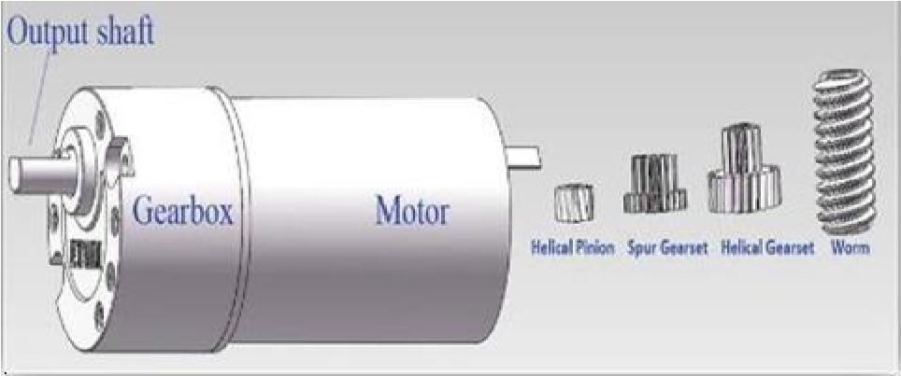

**FIGURE 3.3 :** DC Gear Motor DC Voltage: from 1VDC to 30VDC.

It consists of a electric DC motor and a gearbox or gearhead; these gearheads are used to reduce the DC motor speed, while increase the DC motor torque. Therefore user can get lower speed and higher torque from gear motor.

**Low Speed:** from 0.1rpm to 2000rpm Torque: 0.1kg.cm to 400kg.cm

**Mini size:** diameter from Φ6mm to Φ50mm Low noise Long lifetime

At this moment we have flat DC motors(two sides flat, the other two sides round) and Round DC Motors, the diameter is from Φ8mm to Φ45mm

The motors voltage is from 1VDC to 24VDC, such as 1.5V, 3V,3.7V, 4.5V, 5V, 6V,7.2V, 8.4V, 9V, 12V, 18V, 24V. The motor speed is from 1500rpm to 30000rpm. These DC Motors applications are much more wider, many of the electric and electronic industries are using motor, and science and technology develop day by day, the application and quantity increase fast.

**3.2.1 CONTROLLING A DC MOTOR**

The speed of a DC motor can be controlled by varying its input voltage. A common technique for doing this is to use PWM (Pulse Width Modulation)

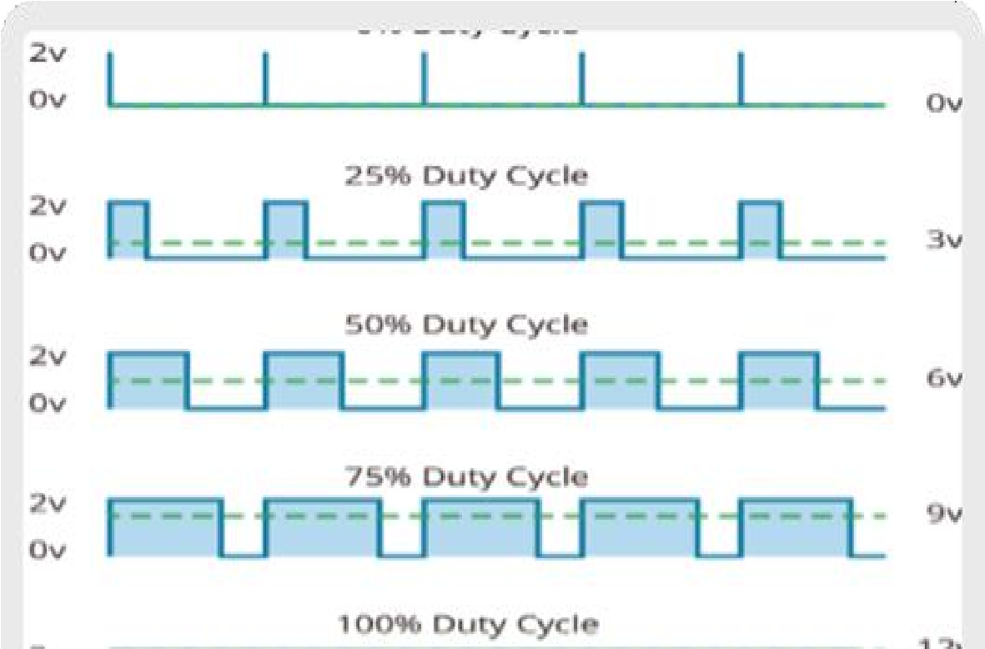

**FIGURE 3.4 :** Duty Cycle for Speed controlling DC motor

Above image illustrates PWM technique with various duty cycles and average voltages. PWM is a technique where average value of the input voltage is adjusted by sending a series of ON-OFF pulses.

In order to have a complete control over DC motor, we have to control its speed and rotation direction. This can be achieved by combining these two techniques.

1. PWM – For controlling speed
2. H-Bridge – For controlling rotation direction PWM – For controlling speed

The average voltage is proportional to the width of the pulses known as Duty Cycle. The higher the duty cycle, the greater the average voltage being applied to the dc motor (High Speed) and the lower the duty cycle, the less the average voltage being applied to the dc motor (Low Speed).

**3.3 MOTOR DRIVER (L293D):**

The L293D is a popular 16-Pin Motor Driver IC. As the name suggests it is mainly used to drive motors. A single L293D IC is capable of running two [DC motors](https://components101.com/motors/toy-dc-motor) at the same time; also the direction of these two motors can be controlled independently.

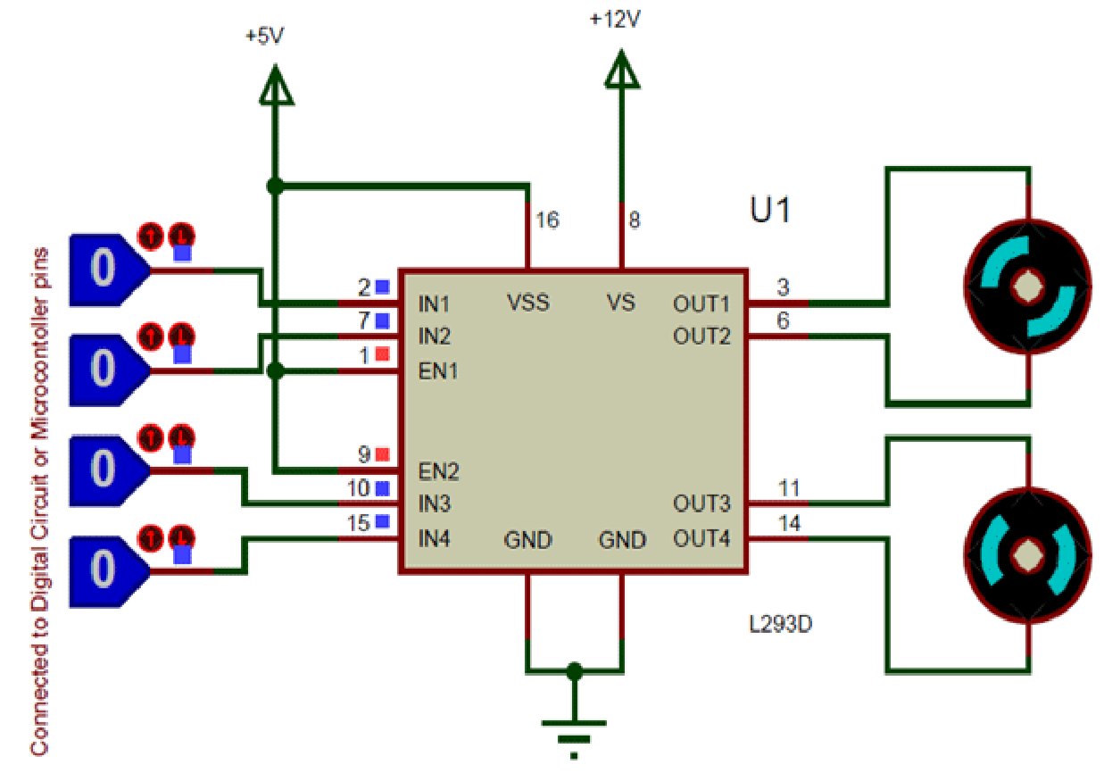

**FIGURE 3.5 :** Interface of Motor Driver with 2 Motors

Using this L293D motor driver IC is very simple. The IC works on the principle of Half HBridge, let us not go too deep into what H-Bridge means, but for now just know that H bridge is a setup which is used to run motors both in clock wise and anti-clockwise direction.

As said earlier this IC is capable of running two motors at the any direction at the same time, the circuit to achieve the same is shown above.

All the Ground pins should be grounded. There are two power pins for this IC, one is the Vss(Vcc1) which provides the voltage for the IC to work, this must be connected to +5V. The Enable pins (Enable 1,2 and Enable 3,4) are used to Enable Input pins for Motor 1 and Motor 2 respectively.

# **Table 3.3 :** Controlling Motor Driver

|  |  |  |
| --- | --- | --- |
| Input 1 = HIGH(5v) | Output 1 = HIGH | Motor 1 rotates in Clock wise Direction |
| Input 2 = LOW(0v) | Output 2 = LOW |
| Input 3 = HIGH(5v) | Output 1 = HIGH | Motor 2 rotates in Clock wise Direction |
| Input 4 = LOW(0v) | Output 2 = LOW |
| Input 1 = LOW(0v) | Output 1 = LOW | Motor 1 rotates in Anti-  Clock wise Direction |
| Input 2 = HIGH(5v) | Output 2 = HIGH |
| Input 3 = LOW(0v) | Output 1 = LOW | Motor 2 rotates in Anti -  Clock wise Direction |
| Input 4 = HIGH(5v) | Output 2 = HIGH |
| Input 1 = HIGH(5v) | Output 1 = HIGH | Motor 1 stays still |
| Input 2 = HIGH(5v) | Output 2 = HIGH |
| Input 3 = HIGH(5v) | Output 1 = LOW | Motor 2 stays still |
| Input 4 = HIGH(5v) | Output 2 = HIGH |

Since in most cases we will be using both the motors both the pins are held high by default by connecting to +5V supply. The input pins Input 1,2 are used to control the motor 1 and Input pins 3,4 are used to control the Motor 2. The input pins are connected to the any Digital circuit or microcontroller to control the speed and direction of the motor. You can toggle the input pins based on the following table to control your motor.

**3.3.1 FEATURES**

* Can be used to run Two DC motors with the same IC.
* Speed and Direction control is possible
* Motor voltage Vcc2 (Vs): 4.5V to 36V
* Maximum Peak motor current: 1.2A
* Maximum Continuous Motor Current: 600mA
* Supply Voltage to Vcc1(vss): 4.5V to 7V
* Transition time: 300ns (at 5Vand 24V)
* Automatic Thermal shutdown is available
* Available in 16-pin DIP, TSSOP, SOIC packages

**3.3.2 APPLICATIONS**

* Used to drive high current Motors using Digital Circuits
* Can be used to drive [Stepper motors](https://components101.com/motors/28byj-48-stepper-motor)
* High current LED‟s can be driven
* [Relay](https://components101.com/5v-relay-pinout-working-datasheet) Driver module (Latching Relay is possible)

**3.4 POWER SUPPLY:**

A power supply is an electrical device that supplies electric power to an electricalload. The primary function of a power supply is to convert electric current from a source to the correct voltage, current, and frequency to power the load. Some power supplies are separate standalone pieces of equipment, while others are built into the load appliances that they power.

Other functions that power supplies may perform include limiting the current drawn by the load to safe levels, shutting off the current in the event of an electrical fault, power conditioning to prevent electronic noise or voltage surges on the input from reaching the load, power factor correction, and storing energy so it can continue to power the load in the event of a temporary interruption in the source power. DC power supplies use AC mains electricity as an energy source. Such power supplies will employ a transformer to convert the input voltage to a higher or lower AC voltage. A rectifier is used to convert the transformer output voltage to a varying DC voltage, which in turn is passed through an electronic filter to convert it to an unregulated DC voltage. The filter removes most, but not all of the AC voltage variations; the remaining AC voltage is known as ripple.

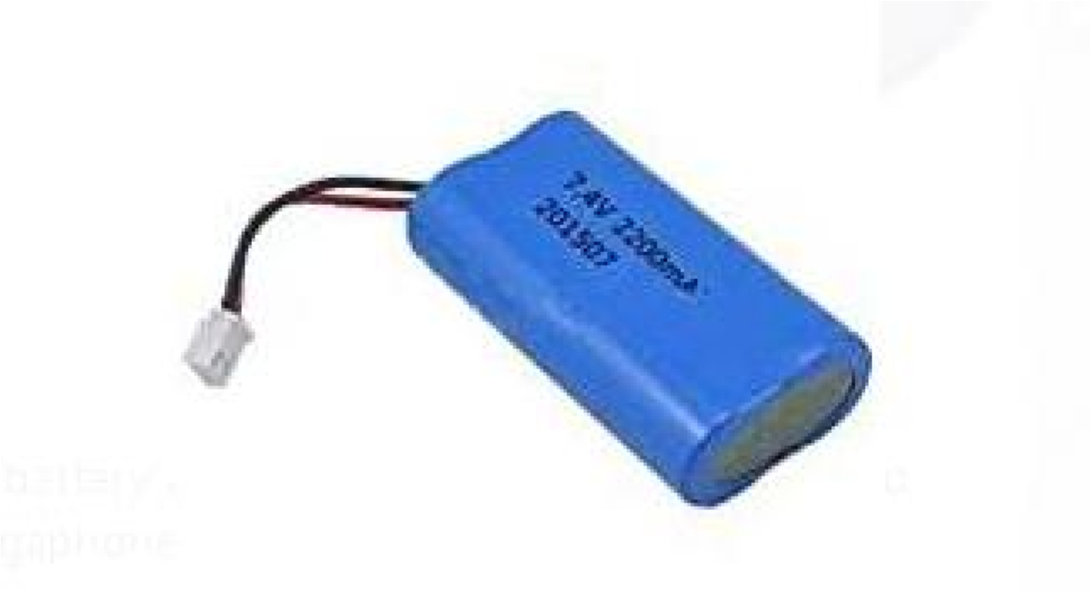

**FIGURE 3.6 :** Lithium-Ion Battery

The electric load's tolerance of ripple dictates the minimum amount of filtering that must be provided by a power supply. In some applications, high ripple is tolerated and therefore no filtering is required. For example, in some battery charging applications it is possible to implement a mains- powered DC power supply with nothing more than a transformer and a single rectifier diode, with a resistor in series with the output to limit charging current.

Lithium-ion is the fastest growing and most promising battery chemistry. Lithium-ion is a low maintenance battery, an advantage that most other chemistries cannot claim. There is no memory and no scheduled cycling is required to prolong the battery's life.

In addition, the self-discharge is less than half compared to nickel-cadmium, making lithium-ion well suited for modern fuel gauge applications. lithium-ion cells cause little harm when disposed. Despite its overall advantages, lithium-ion has its drawbacks. It is fragile and requires a protection circuit to maintain safe operation. Built into each pack, the protection circuit limits the peak voltage of each cell during charge and prevents the cell voltage from dropping too low on discharge. In addition, the cell temperature is monitored to prevent temperature extremes.

**3.4.1 ADVANTAGES OF LITHIUM-ION BATTERY:**

* High energy density - potential for yet higher capacities.
* Does not need prolonged priming when new. One regular charge is all that's needed.
* Relatively low self-discharge - self-discharge is less than half that of nickel-based batteries.
* Low Maintenance - no periodic discharge is needed; there is no memory.
* Specialty cells can provide very high current to applications such as power tools.

**3.5 BLUETOOTH MODULE HC-05**

To setup Wireless Serial Communication, HC-05 Bluetooth Module is most demanding and popular due to its low price and extremely high features. HC-05 Bluetooth Module is an easy to use Bluetooth SPP (Serial Port Protocol) module, designed for transparent wireless serial connection setup. HC-05 Bluetooth module provides switching mode between master and slave mode which means it able to use neither receiving nor transmitting data. This module can be used in Master or Slave Mode and easy switchable between these two modes, By default Slave mode is configured.

**3.5.1 PIN DISCRIPTION OF HC-05 BLUETHOOTH MODULE:**

The HC-05 Bluetooth Module has 6pins. They are as follows:

* **ENABLE:** When enable is pulled LOW, the module is disabled which means the module will not turn on and it fails to communicate.

When enable is left open or connected to 3.3V, the module is enabled i.e., the module remains on and communication also takes place.

* **Vcc:** Supply Voltage 3.3V to 5V
* **GND:** Ground pin
* **TXD & RXD:** TheseS two pins acts as an UART interface for communication

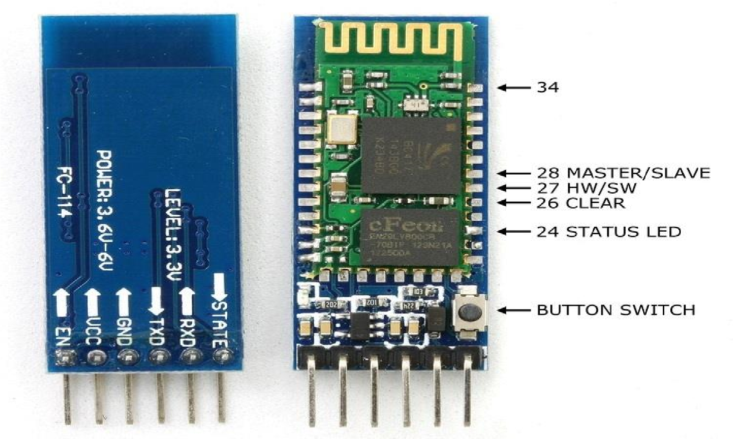

**FIGURE 3.7 :** Bluetooth Module HC-05

* **STATE:** It acts as a status indicator .When the module is not connected to / paired with any other Bluetooth device, signal goes Low.

At this low state, the led flashes continuously which denotes that the module is not paired with other device. When this module is connected to/paired with any other bluetooth device, the signal goes High.

At this high state, the led blinks with a constant delay say for example 2s delay which indicates that the module is paired.

* **BUTTON SWITCH**: This is used to switch the module into AT command mode. To enable AT command mode, press the button switch for a second. With the help of AT commands, the user can change the parameters of this module but only when the module is not paired with any other BT device. If the module is connected to any other bluetooth device, it starts to communicate with that device and fails to work in AT command mode.

* + 1. **CONNECTION OF HC-05 BLUETOOTH MODULE WITH**

**ARDUINO UNO**

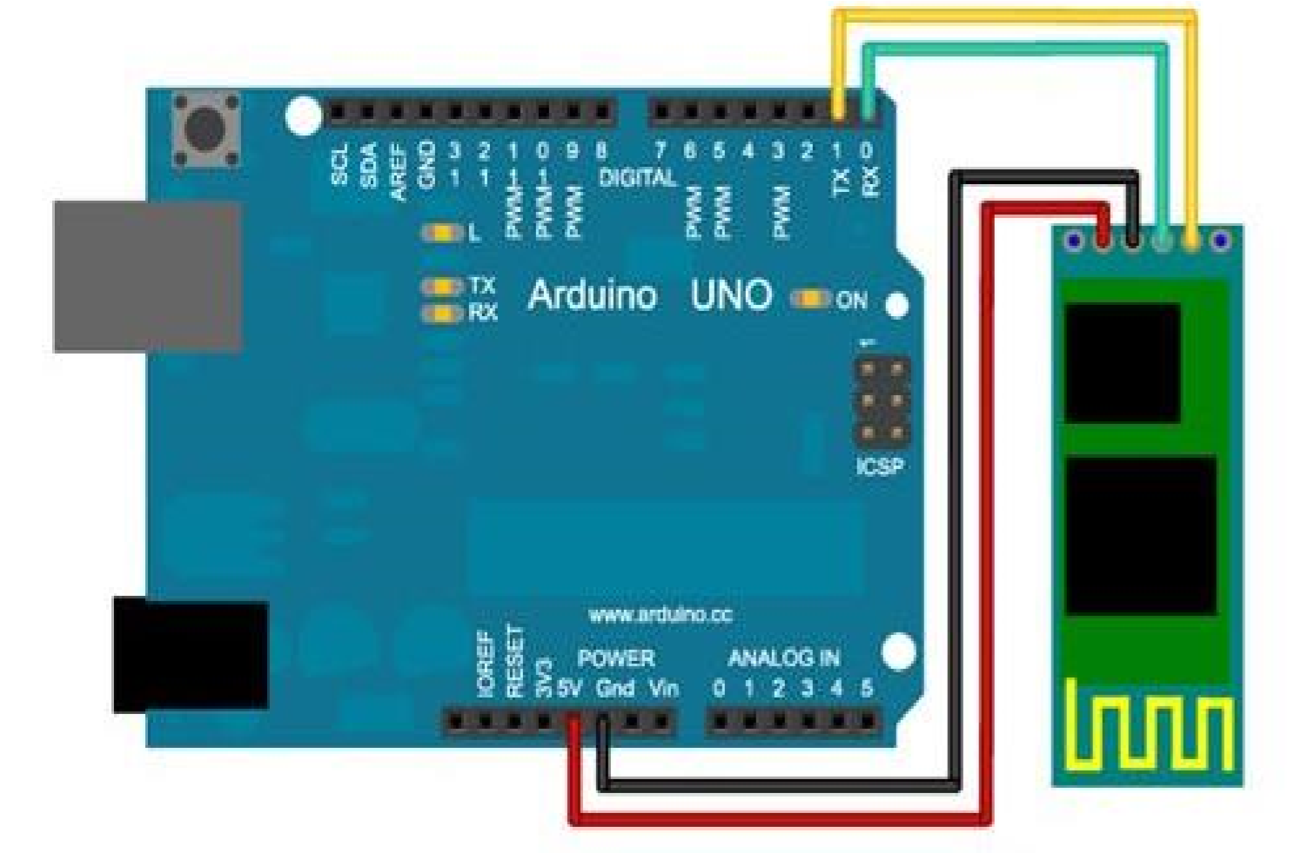

**FIGURE 3.8 :** Interface of HC-05 Bluetooth Module with Arduino UNO

The above figure shows the interface of buletooth module with Arduino UNO. As we know that Vcc and Gnd of the module goes to Vcc and Gnd of Arduino.The TXD pin goes to RXD pin of Arduino and RXD pin goes to TXD pin of Arduino i.e(digital pin 0 and 1).

**Hardware and Software Required:**

HC-05 Bluetooth Module, Arduino Uno, Arduino IDE(1.8.12V).

* + 1. **PROGRAM FOR HC-05 BLUETOOTH MODULE:**

The program given below is the HC-05 bluetooth module program. This process is quite different from others since we are going to use android mobile to control and communicate with Arduino. Here the bluetooth module acts as an interface between our mobile and Arduino board.

Before getting into the execution process, follow the given procedure:

1. First of all, the user should install an application called **Blueetooth RC Controller** from the playstore which is a free application.
2. After installation, pair the bluetooth module to your mobile as like connecting one device to other using bluetooth. The default pairing code is 1234.
3. Upload the related program to the Arduino Uno board. After uploading the code, unplug the USB from the arduino.
4. Connect the bluetooth module with your mobile. Once it is connected you can control the model manually using commends or directions which is already present in the application.

**3.6 SOFTWARE DEVELOPMENT - ARDUINO IDE**

* Before plugging the USB cable to your computer, you need to first install the Arduino IDE.

Go to the Download page on the adruino.cc:



**FIGURE 3.9 :**  Icon to Download the Arduino Software

* For Windows users

There are two choices for Windows version of L: Installer or ZIP file. You're recommended to use the Installer since it will automatically install the driver for Arduino IDE installation. So you can just download it and run the executable file to begin installation. If you download the zip file, you need to unzip the file and install the driver by yourself.

* For Installation

**Step 1:** Find the .exe file just downloaded

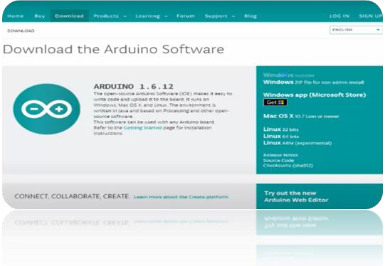

**FIGURE 3.10 :** Welocme Screen 1

**Step 2:** Double click the file and a window will pop up as below. Click **I Agree**



**FIGURE 3.11 :** Setup Screen 2

**Step 3:** Click Next.

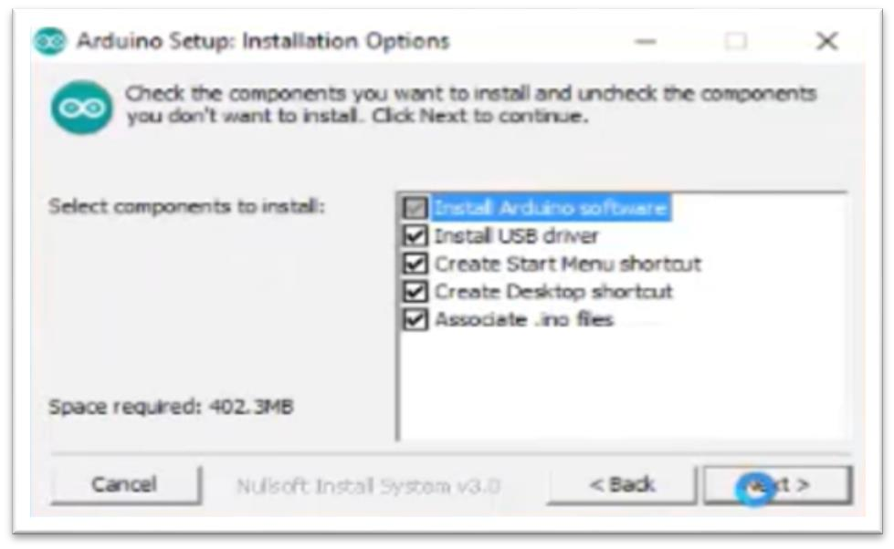

**FIGURE 3.12 :** Setup Screen 3

**Step 4:** Select the path to install. By default, it's set in the C disk: C:\Program

Files\Arduino. You can click Browse and choose another path. Click OK. Then click

Install.

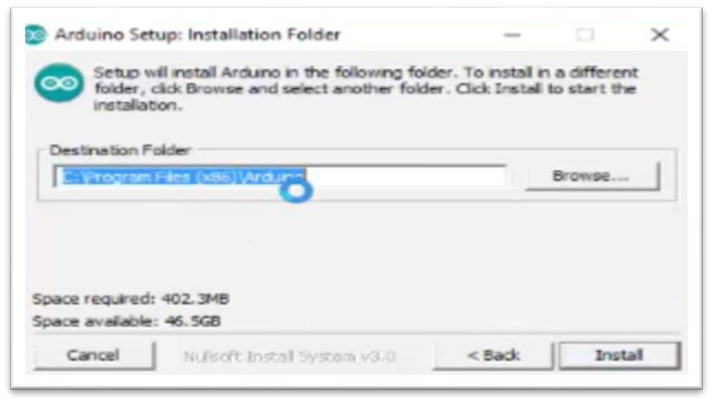

**FIGURE 3.13 :** Setup Screen 4

**Step 5:** After the installation is done, click Close.

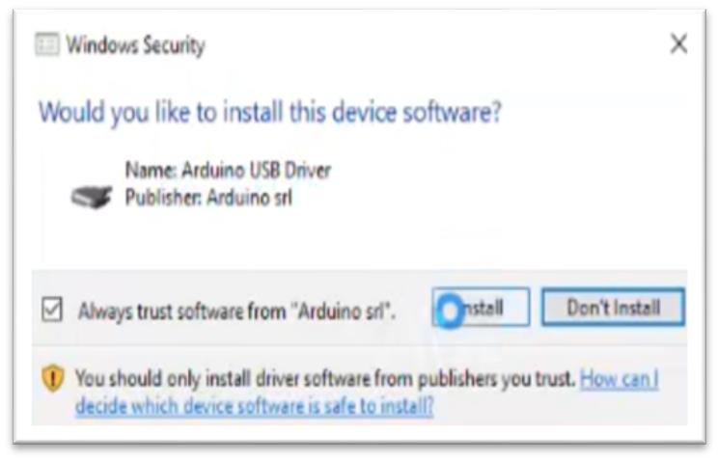

**FIGURE 3.14 :** Ask Permission to Install



**FIGURE 3.15 :**  Installed Window

* Please note that the new IDE may prompt errors when you're compiling code under Windows XP. So if your computer is running on XP, you're suggested to install Arduino 1.0.5 or 1.0.6. Also you can upgrade your computer.
* Plug in the board. Connect the MCU to your computer via a USB cable (type-A to B).
* The cable can be used not only to upload sketches to the board, but also supply power. After plugging in, the green LED on the board labeled with ON, will brighten. The yellow LED, labeled with L, will flicker first and then keep steady on.
* Install the driver. If you downloaded the installer, upon your connecting the board to the computer, the system will help you install the driver automatically.
* After a while, a prompt may appear in the taskbar indicating the driver is installed successfully. It depends on computers. So if you don't see it in yours, it's still OK. You can also check the port on Device Manager.
* Right click on your computer and click Manage. Find Device Manager under Computer Management (local). Then you can see the Mega 2560 at COM54. The other boards are similar. It's normal if yours is different from mine. So now the board is recognized by the computer.

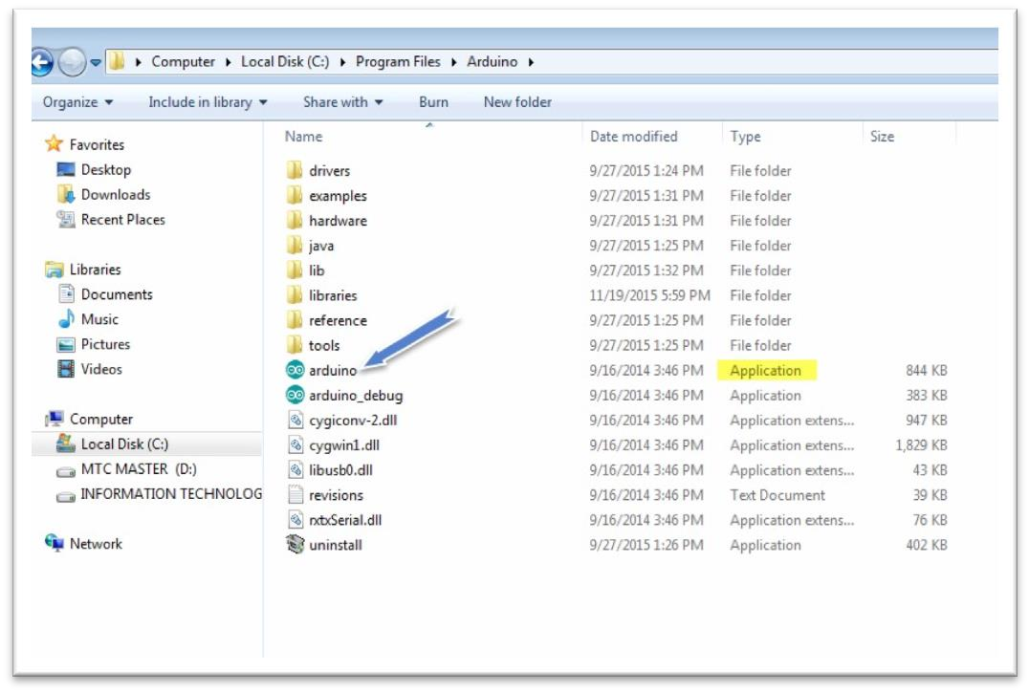

**FIGURE 3.16 :** Setup Screen 5

* If you download the zip file before, when you connect the MCU to the computer, it may not be recognized (it can happen). Then you need to install the driver manually.
* Take the following steps:
  1. Extract the zip file you downloaded. Then right click on Computer and select Management or Device Manager. Find Other Devices.
  2. Right click on Unknown Devices or Arduino board (COmxx) and select Update Driver Software.
  3. Choose the second option, Browse my computer for Driver software.
  4. A window pops up then. Click Browse. Then go to the folder where you just extracted the file.
  5. Go to the drivers folder and click OK -> Next.

It may need a sec.

* 1. Then the system prompts you the driver has been installed successfully. And the driver is for Uno. So the computer can recognize the board now.
  2. Click Close.

➢ **To open the Arduino Software(IDE)**

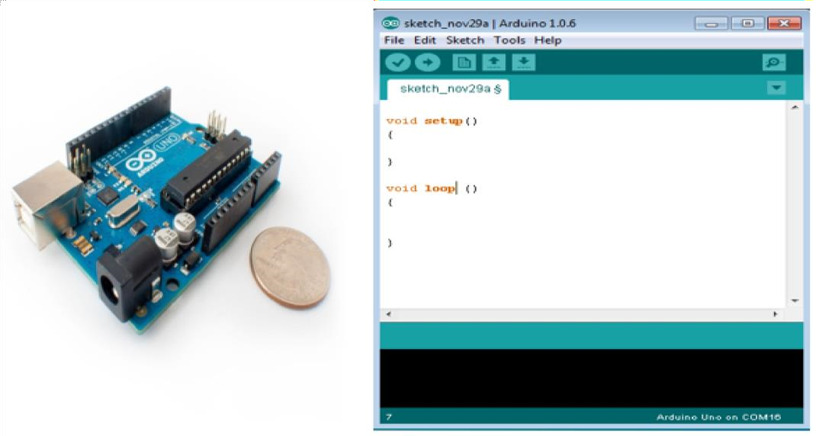

**FIGURE 3.17 :** Setup Screen 6

Double-click the Arduino icon (arduino.exe) created by the installation process Then the Arduino IDE will appear.

**3.7 FLOW CHART**



INITIALISATION OF BLUETOOTH

MODULE AND CONFIGURE THE



START DC MOTORS TO MOVE

ROBORT AND SEED SOWING



START



IF OBSTRAL

DETECTED?



NO



STOP



YES

**FIGURE 3.18 :** Flow Chart